
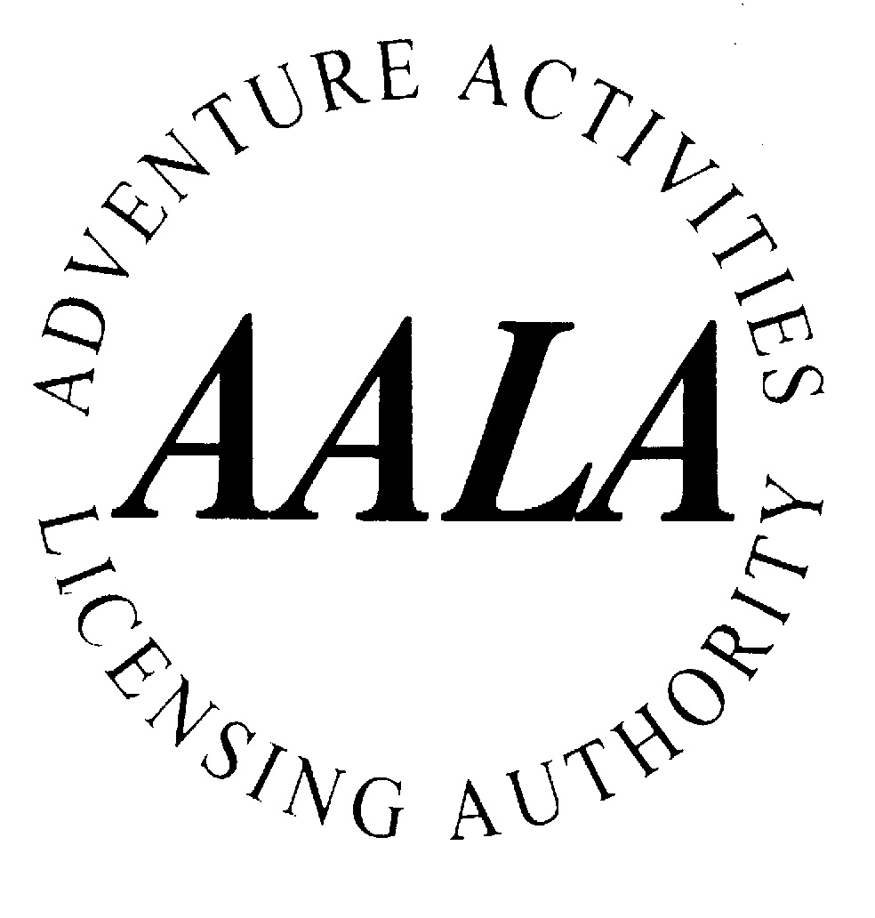

CHILDREN’S KIT LIST & INFORMATION FOR PARENTS & CARERS

High Borrans is a large country house situated in the low fells to the north east of Windermere, in the Lake District National park. The Centre has been owned and run by North Tyneside Council since 1967.

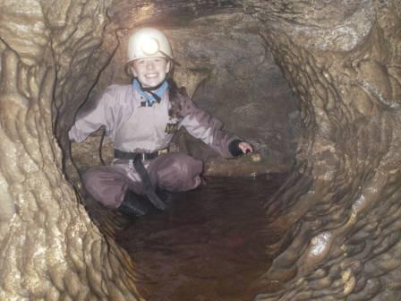
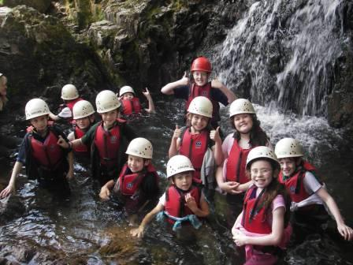
The Centre is set in five acres of wooded land near a small reservoir which is used for canoeing, raft building and swimming. High Borrans is comfortably furnished and decorated. The accommodation is centrally heated. Bedrooms sleep up to six people, and are fitted with bunk beds and all bedding is provided. There are also dining facilities, a games room, library and TV room. We have a team of staff providing the meals and running the house and grounds.

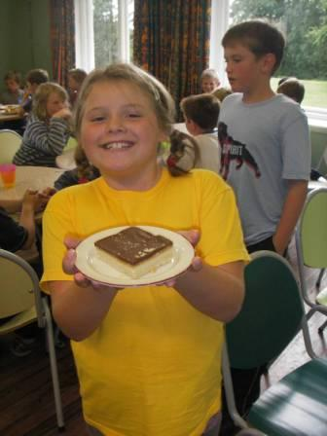
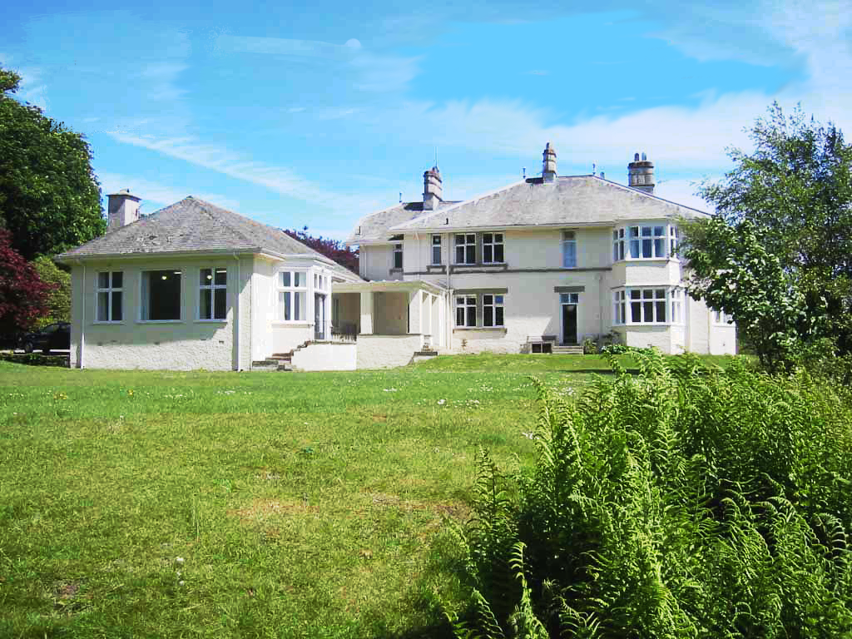


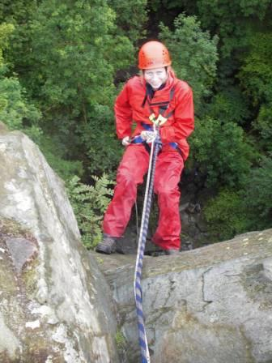

High Borrans employs only experienced and highly qualified outdoor education instructors. The Centre delivers a wide range of adventure and study activities suited to the particular age group attending. Activities take place both on site and in the surrounding countryside (within 40 minute drive by minibus). The course organiser will provide you with more details of the activities your son/daughter will be doing during his or her stay at High Borrans. High Borrans provides all protective outdoor and specialist equipment necessary to carry out chosen activities.

The staff at the High Borrans are proud of the level of care given to the needs and well being of every visitor. We will do everything we can to make your child’s visit happy, enjoyable and safe. To help us achieve this we ask that you complete the information/medical form provided and return it to the organising teacher as soon as possible. This information will be treated in the strictest confidence and the form will be destroyed at the end of the visit. High Borrans safety management systems comply with North Tyneside Council and the Adventure Activities Licensing Service. Parents are asked to acknowledge the small residual risk that is inherent in the nature of outdoor adventurous activities.

Please turn the page for information about what your son or daughter needs to bring.

YOUR SON/DAUGHTER SHOULD BRING:

We provide (free of charge) any specialist equipment required for chosen activities. This loan includes waterproof clothing, walking boots, wellington boots, rucksacks, lunch boxes and water bottles. If your son/daughter already has any of this equipment they can be bring it to use at the Centre. We will check clothing and equipment’s suitability for activities and the weather.

Your son/daughter does need to come equipped with enough warm and comfortable personal clothing suited to the activities. The Lake District weather may be cold, wet and windy even in summer and during the activities your son/daughter may choose to end up wet or muddy. We have a good drying room but spares of OLD clothes, socks and shoes are needed. Please put your child’s name on everything!

If your son/daughter wishes to bring a mobile phone please check with their course organiser. The instructors carry mobile phones and are in contact with the Centre during activities. At High Borrans mobile phone reception is variable and we do have a landline phone in the staff room for emergency calls. We ask parents and guardians not to make social incoming calls as they may be distracting and disrupt activities. However Centre and visiting staff are happy to speak with you if you have any concerns regarding your son/daughter’s welfare during the visit, and contact arrangements are in place in the case of an emergency.

FOR USE ON ACTIVITY SESSIONS:

- Several pairs of comfortable trousers eg track suit bottoms (synthetic fibres preferable)
but not denim jeans. (Shorts in summer and winter)
- A warm top/jacket such as a thick fleece or their usual outdoor coat
- A variety of tops such as T shirts, sweat shirts, fleeces and jumpers
- Several pairs of thick socks to wear with walking boots or Wellingtons
- Hats, scarves and gloves are essential in winter
- Sun hats and sun glasses can prevent headaches in summer and sun cream is essential

- Swimwear
- Old plimsolls/trainers/water shoes for lake-based activities
- Old training shoes (2 pairs useful) which may be used instead of boots

OTHER KIT SHOULD INCLUDE:

- Personal choice of clothes for leisure time around the centre, underwear and nightwear
- Toiletries including soap, towel, toothbrush and toothpaste.
- Medication – please inform your party leader of any medication your child is bringing and make appropriate arrangements with them for safe keeping. INHALERS: Asthma UK advises that all visitors should bring 2 inhalers with them, one for use and a new, boxed and sealed second one in reserve. They feel this is ‘the norm’ for asthmatics to ensure the person always has a full and in date inhaler. ADRENALINE -PENS: you should consult your GP about having sufficient epi-pens for going into remote settings where paramedic help may be 1-2 hours away (i.e. having additional pens).
- Soft shoes – we require slippers or light indoor shoes such as trainers to be worn around the house
- A small amount of pocket money – there is little to spend money on during the visit but we do run a shop selling sweets and souvenirs.
- Hand wipes for cleaning hands before eating picnic lunches whilst out on activity
- Plastic bags for wet clothing

OPTIONAL EXTRAS:

- Books, indoor games, personal music systems and camera

